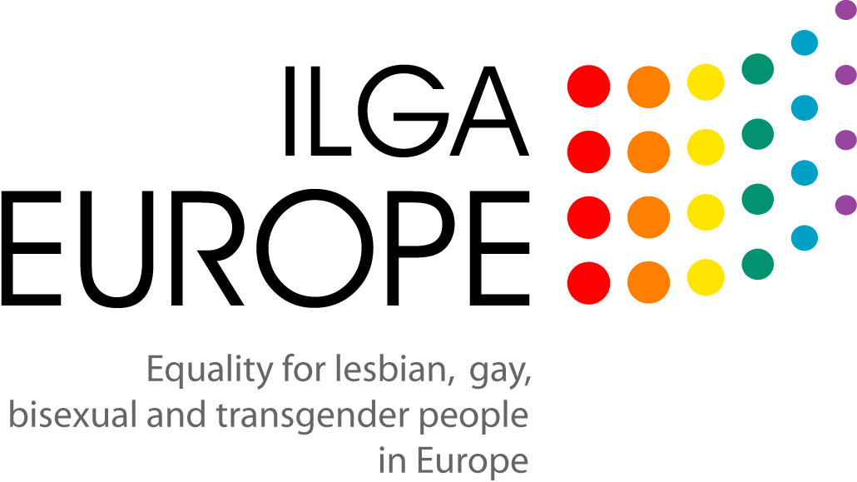

Evidence of discrimination based on sexual orientation outside employment
Submitted by ILGA-Europe following its written responses to the
European Commission Consultation on New Anti-Discrimination Measures
(December 2007)

ILGA-Europe is submitting the following annotated bibliography as complementary information to the written response to the European Commission’s consultation sent on 15 October. The reports, surveys and research cited in this document provide further evidence of discrimination of the discrimination that lesbian, gay and bisexual people in Europe experience in access to healthcare, in education, in goods and services because of their sexual orientation.

General surveys on discrimination based on sexual orientation

France
- Rapport annuel de SOS-Homophobie (Annual Reports on homophobia in France), www.sos-homophobie.org/index.php?menu=4&menu_option=42

These reports compile the complaints and cases of homophobia received by the organization SOS-Homophobie every year in France. These include testimonies of discrimination in goods and services, in public spaces, at school, with the police, in sports and leisure activity, in health care. SOS-Homophobie has been producing these reports annually since 2000.

Finland

- Syrjintä Suomessa (Discrimination in Finland) 2006, Outi Lepola & Susan Villa (ed.) http://www.ihmisoikeusliitto.fi/Syrjinta.pdf

Chapter 2 concentrates on examining discrimination on the grounds of diversity of sexual orientation and gender. The report explains that, as regards the standing of these groups, several changes have taken place in the past years, which have positively affected their rights and equality. However, in areas such as working life, leisure time and social and health services, practices that discriminate these groups still exist. The development of the young and children is affected by the models that are discriminative towards gender and sexual minorities.

Ireland

- Poverty - Lesbians and Gay Men: The Economic and Social Effects of Discrimination, Gay and Lesbian Equality Network & Nexus Research Co-operative, Published by Combat Poverty Agency, Ireland, 1995.
www.combatpovertypublications.ie/prodtype.asp?strParents=&CAT_ID=187&numRecordPosition=1

This study examines how discrimination affects people’s lives with regard to education, training, employment, relationships with family and friends, service provision, access to resources such as housing and benefits, health, emigration, harassment and violence. It analyses the strategies used by lesbians and gay men to avoid, cope with or resist discrimination.

Poland
- Situation of bisexual and homosexual persons in Poland 2005 and 2006 report, Edited by Marta Abramowicz, Campaign against Homophobia and Lambda Warsaw Association, Warsaw 2007 (http://www.ilga-europe.org/europe/guide/country_by_country/poland/report_situation_of_bisexual_and_homosexual_persons_in_poland_2005_2006)

Slovenia
- Alenka Švab and Roman Kuhar, The Unbearable Comfort of Privacy - The Everyday Life of Gays and Lesbians, 2005 (www.mirovni-institut.si/eng_html/publications/pdf/MI_gay_eng.pdf)

Sweden
    - Summary of complaints concerning schools, public services, access to goods and services, including housing, are available at http://www.homo.se/o.o.i.s/2061.

Health

General
    - Report of the Special Rapporteur, Paul Hunt, on the right of everyone to the enjoyment of the highest attainable standard of physical and mental health (E/CN.4/2003/58, 13 February 2003)

In this report, the Special Rapporteur recognized that “Discrimination on grounds of gender, race, ethnicity and other factors is a social determinant of health. Social inequalities, fuelled by discrimination and marginalization of particular groups, shape both the distribution of diseases and the course of health outcomes amongst those afflicted.” The Special Rapporteur also recalled that non-discrimination is among the most fundamental principles of international human rights law. According to the UN Committee on Economic, Social and Cultural Rights, the Covenant on ESC rights “proscribes any discrimination in access to health care and underlying determinants of health, as well as to means and entitlements for their procurement, on the grounds of race, colour, sex, language, religion, political or other opinion, national or social origin, property, birth, physical or mental disability, health status (including HIV/AIDS), sexual orientation (emphasis added) and civil, political, social or other status, which has the intention or effect of nullifying or impairing the equal enjoyment or exercise of the right to health”. (General Comment No. 14, para.18)

Finland
    - From heterosexual assumption to pluriformity - Lesbians, gay men, bisexuals and transgendered people in health and social care (Hetero-olettamuksesta moninaisuuteen - lesbot, homot, bi- ja trans-ihmiset sosiaali- ja terveyspalveluiden asiakkaina.) Lehtonen, Jukka & Nissinen, Jussi & Socada, Maria (eds.), Helsinki: Edita. 1997

Ireland

    - GLEN Mental Health Report, Brian Dillon & Eoin Collins, Prepared for
Gay HIV Strategies and The Northern Area Health Board (2003), www.glen.ie/public/pdfs/Mental%20Health%20Report%202004.pdf

This report describes how the experience of marginalisation can impact on LGB people’s general and emotional health and their use of health and social services. In addition to this, international research has highlighted the negative impact that marginalisation, stigmatisation and discrimination can have on the mental health and well-being of some LGB people. Some of the key findings from research are: (1) LGB people are more likely to attempt suicide compared to their heterosexual peers; (2) LGB people are also more likely to have substance abuse or mental health problems (depression and anxiety), which are known risk factors for both attempted and completed suicide.

Hungary and Romania

    - Accessing Health: the Context and the Challenges for LGBT People in Central and Eastern Europe, S.Quinn, ILGA-Europe, 2006.

This 2005 ILGA-Europe study was conducted in five countries, including Romania and Hungary, and looked at the context and challenges faced by LGBT people in accessing health care systems.

Sweden

    - Health and discrimination project, Swedish National Institute for Public Health, A joint project between DO, FHI, HO and HomO, 2006 www.fhi.se/upload/ar2006/Ovrigt/FactSheetHealthDiscrimination.pdf

United Kingdom
    - Harassment and sexual orientation in the health sector, by Ruth Hunt and Katherine Cowan
www.stonewall.org.uk/documents/reporting_homophobia_in_the_health_sector.pdf

Education

General
    - Social Exclusion of LGBT youth in Europe, Judit Takács, ILGA-Europe and IGLYO publication, 2006 www.ilga-europe.org/europe/publications/non_periodical/

This European-wide survey carried out by ILGA-Europe and the International Gay and Lesbian Youth Organisation (IGLYO) found that education is the field in which LGBT youth experience most discrimination: 61.2% of young LGBT people in Europe responded that they had experienced discrimination at school. More than half of the respondents to the survey (53%) said that they had experienced bullying at school (e.g. verbal attacks, harassment, threats, physical violence), while 43% of youth said to have encountered prejudice in curriculum and teaching content (e.g. lack of representation, expression of prejudice/negative representation of LGBT issues in curriculum; homonegative attitudes or passivity from teachers).

France
    - Enquete sur l’homophobie en milieu scolaire (Survey on homophobia in schools) SOS-Homophobie (2005/2006) www.sos-homophobie.org/documents/analyse_enquete_milieu_scolaire.pdf

Finland
    - Heterosexuality in school curricula - the experiences of non-heterosexual students as a starting point (Heteroseksuaalisuus oppikirjoissa - lähtökohtana ei-heteroseksuaalisten nuorten kokemukset). In Helve, Helena (ed.): Nuorten arki ja muuttuvat rakenteet.Nuorisotutkimus 2000. Helsinki: Suomen Nuorisotutkimusseura ry

Ireland
**A complete list of research on LGBT issues in education in Ireland is available on the website of the Gay and Lesbian Equality Network www.glen.ie/education/resources.html

- Survey of Teachers On Homophobic Bullying in Irish Second-Level Schools, James Norman, Published by Dublin City University (November 2004)
http://www.belongto.org/docs/research_schooling_sexualities.pdf

This research found that a majority of teachers (79%) were aware of instances of verbal homophobic bullying. A significant number (16%) were aware of physical bullying in their school. The research found that 90% of respondents reported that their school's anti-bullying policy did not include any reference to lesbian and gay related bullying.

    - Straight Talk: An Investigation of Attitudes and Experiences of Homophobic Bullying in Second-Level Schools by James Norman, Miriam Galvin (January 2006) Gender Equality Unit of the Department of Education & Science, Dublin City University
www.dcu.ie/education_studies/schooling_sexualities/schoolingsexualities-phase2report.pdf

Portugal
- Observatório de educacão LGBT - Relatório sobre Homofobia e Transfobia (report on homophobia and transphobia), by rede ex aequo – associação de jovens lésbicas, gays, bissexuais, transgéneros e simpatizantes, Lisbon, September 2006
http://www.ex-aequo.web.pt/arquivo/observatorio/OE2006.pdf

This report includes data collected by the youth groups across Portugal in 2006 on the incidence of homophobic and transphobic bullying, on the attitude of teachers, and on the consequences of discrimination in schools on health of youth and on school performance.

Spain
    - Homofobia en el sistema educativo (Homophobia in the education system), Comision de Educacion de COGAM Jesús Generelo Lanaspa (COGAM and FELGT) and José Ignacio Pichardo Galán, Departamento de Antropología Social de la Universidad Autónoma de Madrid.
www.felgt.org/_felgt/archivos/4066_es_Homofobia%20en%20el%20Sistema%20Educativo%202005.pdf?cl=es-ES

A survey on the perception of students about homosexuality and transsexuality, on the experience of LGBT students and on responses to homophobia and transphobia.

United Kingdom
    - The School Report - The experiences of young gay people in Britain’s schools by Ruth Hunt and Johan Jensen, Stonewall, 2007
http://www.stonewall.org.uk/documents/school_report.pdf

This report produced by Stonewall presents the results of a survey conducted with more than 1100 of those young people, the largest poll of its kind ever carried out in the UK. It reveals that homophobic bullying is almost epidemic in Britain's schools: Almost two thirds of young gay people at secondary school (65%) have experienced homophobic bullying. In faith schools, that figure rises to three in four. Homophobic language is endemic in schools, and more often than not teachers turn a blind eye to it. Seven out of ten of these young people say the bullying affects their school work. And half have skipped school to avoid the bullying.

    - Homophobia, Sexual Orientation and Schools: a Review and Implications for Action, Ian Warwick, Elaine Chase and Peter Aggleton - Thomas Coram Research Unit, Institute of Education, University of London, 2004
www.dfes.gov.uk/research/data/uploadfiles/RR594.pdf

This report looks at research findings on the extent of homophobic bullying in schools in the UK. According to this report, estimates of general bullying among young people in schools are understood to be around 10-20% but can be up to 60% dependent on the definition of bullying used and schools sampled. It has been estimated that between 30-50% of same-sex attracted young people in secondary schools will have directly experienced homophobic bullying. Among teachers in secondary schools in England and Wales, around 82% are reported to be aware of verbal homophobic incidents and 26% are aware of physical homophobic incidents. In terms of the impact of homophobic bullying, homophobic incidents directed towards same-sex attracted young people are reported to have led to elevated rates of suicide and suicide attempts, absenteeism from school, truancy, limited achievement and the desire to stay on in education.

    - LGBT Youth research report on how homophobic incidents and homophobia is dealt with in schools, S. O'Loan, F. McMillan, S. Motherwell (LGBT Youth Scotland) and A. Bell, R. Arshad (University of Edinburgh), June 2006. www.scotland.gov.uk/Publications/2006/05/25091604/0

This report was published by Schools Division, Scottish Executive Education Department. It includes a literature review of existing research data on discrimination at school and a survey on bullying in Scottish schools.

Goods and services

Lithuania

    - Office of the Equal Opportunities Ombudsperson Annual report 2005
www.lygybe.lt/ci.admin/Editor/assets/ataskaita2005eng.pdf

The report presents two complaints brought before the Ombudsperson. It also says: “It should be to note that all persons who submitted complaints and asked for verbal advice were men who felt their rights were violated, mostly in the area of goods and services provision.” (p.17)

United Kingdom
    - Getting Equal: Proposals to Outlaw Sexual Orientation Discrimination in the Provision of Goods & Service (www.stonewall.org.uk/documents/getting_equal_march_2006.pdf)

Slovenia

    - Recent case from Slovenia – Information received from two Slovene organisations (SKUC-LL and Legebitra)
On 11th of October 2007, a lesbian couple was thrown out from the Ljubljana's bar, named “Orto Bar”. The security guy noticed through the video surveillance of the bar that the girls were kissing each other, so he approached them and requested that they immediately leave the bar. He said that “Orto Bar” is “not that kind of bar” and that they should go to “that kind” of bar where “that” is allowed. He also said that their behaviour might “upset” somebody and therefore they have to “sustain from it”. They were told that have to learn that all guests are not used to differences. The girls asked him, if he is a homophobic, but he didn’t react, he just repeated his request. The girls then complained to the owner of the bar, who did say that they can return to the bar, but at the same time he added, that the Orto Bar is a “heterosexual bar”. From his words it wasn’t clear that he is sorry because of the incident.

The limitation of the free movement and unwilling removal of two girls from Orto Bar was an unlawful act, which contained elements of the discrimination on the basis of sexual orientation. If the security guy followed the instructions of his employer this means discriminatory instructions, which is also a form of illegal discrimination. Harassment and violence toward gays and lesbian in the bars is evident in recent years, the streets of Ljubljana are not safe for GLBT people. GLBT people are often victims of homophobic harassment, violence and hate speech in the streets and in public spaces such as bars, pubs, shops, during pride parades, etc. However the violators remain mainly non-identified and non-sanctioned. The above mentioned homophobic incident is identical to the event from 2001, when two gay men were forbidden the entrance to Cafe Galerija in Ljubljana by the security personnel.

Lesbian section SKUC-LL was alarmed about the unfortunate event immediately. Because the lesbian couple wished to remain anonymous we decided to gain public attention without exposing the victims. We published a special media release informing the public about the incident, and calling upon the responsible institutions to take measures. We informed the police, the Ombudsman’s office, governmental Office for equal opportunities and local authorities. Some street actions were also organized in front of the bar. There was a quick and intense reaction of the media to our press release, showing interest in this issue. However it is interesting that that bar, which acted homophobic and discriminatory, issued their own press release accusing SKUC-LL. They stated that we are “abusing this event with the purpose of our self-promotion” and that our intentions are “evil”.

General surveys on public perception of sexual orientation

*As mentioned in the written response submitted by ILGA-Europe on 15 October, in considering the evidence of discrimination on the ground of sexual orientation, it is important to take into consideration the interconnection between visibility of LGB people (“being out” and being with a partner of the same sex), the ability to name and identify discrimination, and to claim rights publicly.

In this context, it is important to consider the public attitudes towards homosexuality. Below are references to recent public attitude surveys from some EU member states.

Cyprus
- Attitudes and perceptions of the public towards homosexuality - A report prepared for the Office of the Commissioner for Administration (Ombudsman) by the Research Center Cyprus College (sent in an attachment)

Hungary
- How to put equality into practice? Anti-discrimination and equal treatment policymaking and LGBT people (Chapter 2 on “Social visibility and acceptance of LGBT people in Hungary”), Judit Takács, Új Mandátum Kiadó, Budapest, 2007.
www.policy.hu/takacs/books/isbn9639609655/

This chapter includes a comparative analysis of opinion poll findings about homosexuality (including attitudes towards marriage, adoption) between Hungary and other European member states.

Latvia
- Latvians’ Attitudes towards sexual minorities: dimensions and ‘Temperature’, Viktor Makarov, Marketing and Public Opinion Research Centre SKDS (with support from Soros Foundation), Riga, 2006
www.ilga-europe.org/europe/guide/country_by_country/latvia/latvians_attitudes_towards_sexual_minorities_dimensions_and_temperature

There were 754 respondents to the questionnaires; 93% of the responses came from youth from within the EU. In Takacs, J., Social Exclusion of LGBT youth in Europe, ILGA-Europe and IGLYO publication, 2006. www.ilga-europe.org/europe/publications/non_periodical/

